

**Project Report**

**SUBMITTED TO:**

Tasnim Ahmed.

Lecturer.

Daffodil International University.

**SUBMITTED BY:**

**Group Name: “Delta”**

**Group Members:**

1. Md. Anisur Rahman Rony (162-15- 7880)
2. Meherin Amir (162-15-7922)
3. Nujhat Tabassum Amithy (162-15-7750)

**Project Title:** **“Design a logo with OpenGL tools”**

Group Number: 2.

Course Code: CSE 422.

Course Title: Computer Graphics Lab.

Section: E.

Department of Computer Science and Engineering.

**Logo of Super Human**

In this project, we have made the logo of super human using OpenGL tools. We made three logos. They are:

(1) Logo of Thor

(2) Logo of Batman

(3) Logo of Superman

The code and output figure of each logo are given below:

**Code of Thor Logo**

#include<stdio.h>

#include<GL/gl.h>

#include<GL/glut.h>

void display(void)

{

glClear(GL_COLOR_BUFFER_BIT);

//1

glBegin(GL_POLYGON);

glColor3f(0.0, 0.0, 0.0);

glVertex2f(290.0,340.0);

glVertex2f(790.0,340.0);

glVertex2f(790.0,580.0);

glVertex2f(290.0,580.0);

glEnd();

glFlush ();

//2

glBegin(GL_POLYGON);

glColor3f(0.0, 0.0, 0.0);

glVertex2f(456.0,580.0);

glVertex2f(623.0,580.0);

glVertex2f(593.0,630.0);

glVertex2f(486.0,630.0);

glEnd();

glFlush ();

//3

glBegin(GL_POLYGON);

glColor3f(0.0, 0.0, 0.0);

glVertex2f(250.0,370.0);

glVertex2f(280.0,345.0);

glVertex2f(280.0,575.0);

glVertex2f(250.0,550.0);

glEnd();

glFlush ();

//4

glBegin(GL_POLYGON);

glColor3f(0.0, 0.0, 0.0);

glVertex2f(800.0,345.0);

glVertex2f(830.0,370.0);

glVertex2f(830.0,550.0);

glVertex2f(800.0,575.0);

glEnd();

glFlush ();

//5

glBegin(GL_POLYGON);

glColor3f(0.0, 0.0, 0.0);

glVertex2f(510.0,340.0);

glVertex2f(510.0,330.0);

glVertex2f(570.0,310.0);

glVertex2f(570.0,340.0);

glEnd();

glFlush ();

//6

glBegin(GL_POLYGON);

glColor3f(0.0, 0.0, 0.0);

glVertex2f(510.0,320.0);

glVertex2f(510.0,290.0);

glVertex2f(570.0,270.0);

glVertex2f(570.0,300.0);

glEnd();

glFlush ();

//7

glBegin(GL_POLYGON);

glColor3f(0.0, 0.0, 0.0);

glVertex2f(510.0,280.0);

glVertex2f(510.0,250.0);

glVertex2f(570.0,230.0);

glVertex2f(570.0,260.0);

glEnd();

glFlush ();

//8

glBegin(GL_POLYGON);

glColor3f(0.0, 0.0, 0.0);

glVertex2f(510.0,240.0);

glVertex2f(510.0,210.0);

glVertex2f(570.0,190.0);

glVertex2f(570.0,220.0);

glEnd();

glFlush ();

//9

glBegin(GL_POLYGON);

glColor3f(0.0, 0.0, 0.0);

glVertex2f(510.0,200.0);

glVertex2f(510.0,170.0);

glVertex2f(570.0,150.0);

glVertex2f(570.0,180.0);

glEnd();

glFlush ();

//10

glBegin(GL_POLYGON);

glColor3f(0.0, 0.0, 0.0);

glVertex2f(510.0,160.0);

glVertex2f(510.0,130.0);

glVertex2f(570.0,110.0);

glVertex2f(570.0,140.0);

glEnd();

glFlush ();

//11

glBegin(GL_POLYGON);

glColor3f(0.0, 0.0, 0.0);

glVertex2f(510.0,120.0);

glVertex2f(510.0,90.0);

glVertex2f(570.0,90.0);

glVertex2f(570.0,100.0);

glEnd();

glFlush ();

}

void init (void)

{

glClearColor(0.0,0.5,0.5,0.0);

glMatrixMode(GL_PROJECTION);

glLoadIdentity();

gluOrtho2D(0.0,1100.0,0.0,700.0);

}

int main(int argc, char** argv)

{

glutInit(&argc, argv);

glutInitDisplayMode(GLUT_SINGLE | GLUT_RGB);

glutInitWindowSize(1100, 700);

glutInitWindowPosition(250, 0);

glutCreateWindow("Thor Logo");

glutDisplayFunc(display);

init();

glutMainLoop();

return 0;

}

**Output Figure of Thor Logo**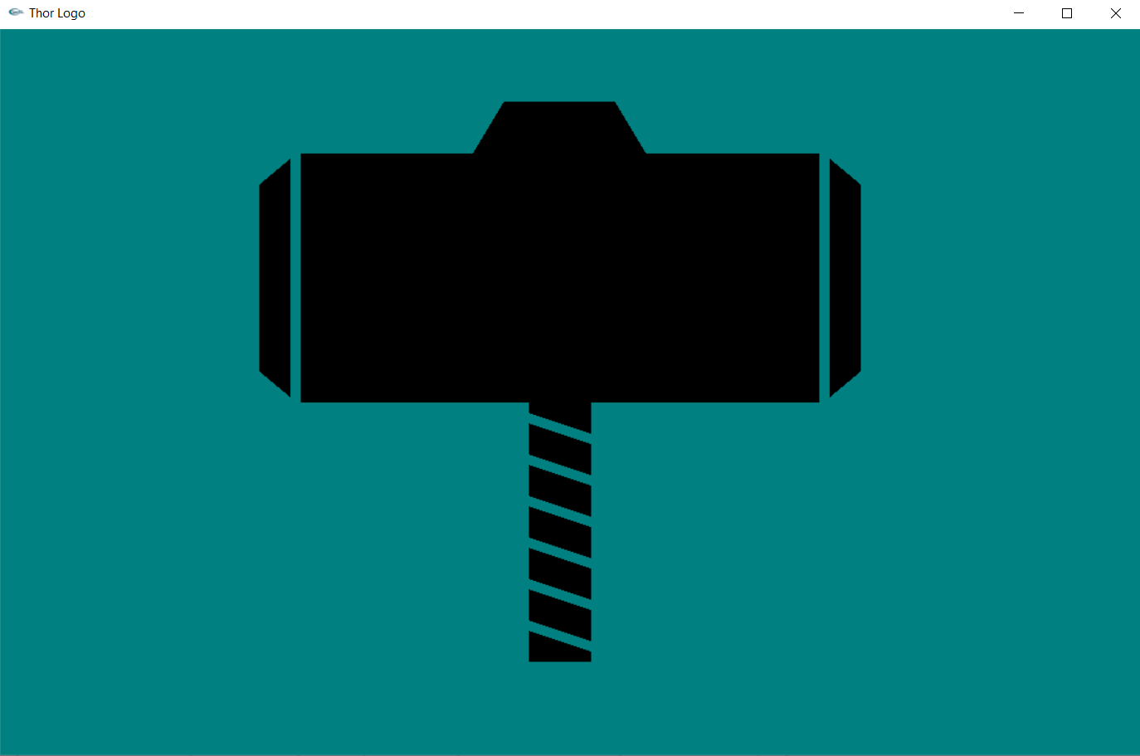

**Code of Batman Logo**

#include<stdio.h>

#include<GL/gl.h>

#include<GL/glut.h>

#include<cmath>

using namespace std;

int m=0;

void draw_line(int x, int y, int sizes, int num)

{

for(int a=x, b=y, c=0; c<num; c++, a+=sizes)

{

glBegin(GL_POLYGON);

glVertex2i(a,b);

glVertex2i(a+sizes,b);

glVertex2i(a+sizes,b+sizes);

glVertex2i(a,b+sizes);

glEnd();

}

}

void vertical_line(int x, int y, int sizes, int num)

{

for(int a=x, b=y, c=0; c<num; c++, b+=sizes)

{

glBegin(GL_POLYGON);

glVertex2i(a,b);

glVertex2i(a+sizes,b);

glVertex2i(a+sizes,b+sizes);

glVertex2i(a,b+sizes);

glEnd();

}

}

void temp(void)

{

glClear(GL_COLOR_BUFFER_BIT);

glPointSize(5);

int sizes=25, blocks=17;

int x=9*sizes, y=3*sizes;

glColor3ub(0, 0, 0);

draw_line(x, y, sizes, blocks);

x=9*sizes, y=4*sizes;

//blocks;

for(int a=0; a<=5; a++)

{

glColor3ub(250, 250, 0);

draw_line(x, y, sizes, blocks);

glColor3ub(0, 0, 0);

draw_line(x-sizes, y, sizes, 1);

draw_line(x+(blocks*sizes), y, sizes, 1);

x = x-sizes;

y = y+sizes;

blocks+=2;

}

x=3*sizes, y=10*sizes;

for(int a=0; a<7; a++)

{

glColor3ub(250, 250, 0);

draw_line(x, y, sizes, 29);

glColor3ub(0, 0, 0);

draw_line(x-sizes, y, sizes, 1);

glColor3ub(0, 0, 0);

draw_line(x+(29*sizes), y, sizes, 1);

y+=sizes;

}

x=4*sizes, y=17*sizes, blocks=27;

for(int a=0; a<=5; a++)

{

glColor3ub(250, 250, 0);

draw_line(x, y, sizes, blocks);

glColor3ub(0, 0, 0);

draw_line(x-sizes, y, sizes, 1);

draw_line(x+(blocks*sizes), y, sizes, 1);

y+=sizes;

x+=sizes;

blocks-=2;

}

x=9*sizes;

glColor3ub(0, 0, 0);

draw_line(x, y, sizes, blocks+2);

x=4*sizes, y=11*sizes;

blocks=5;

for(int a=0; a<6; a++)

{

vertical_line(x, y, sizes, blocks);

x+=sizes;

y-=sizes;

blocks+=2;

}

blocks-=2;

y+=sizes;

vertical_line(x, y, sizes, blocks);

y-=sizes;

x+=sizes;

blocks=12;

vertical_line(x, y, sizes, blocks);

y=20*sizes;

vertical_line(x, y, sizes, 1);

x+=sizes;

y=7*sizes;

blocks=9;

for(int a=0; a<2; a++)

{

vertical_line(x, y, sizes, blocks);

x+=sizes;

y+=sizes;

blocks--;

}

blocks++;

vertical_line(x, y, sizes, blocks);

x+=sizes;

y-=sizes;

blocks=14;

vertical_line(x, y, sizes, blocks);

x+=sizes;

y-=(2*sizes);

blocks=15;

vertical_line(x, y, sizes, blocks);

x+=sizes;

y-=(sizes);

blocks=16;

vertical_line(x, y, sizes, blocks);

x+=sizes;

y+=(sizes);

blocks=15;

vertical_line(x, y, sizes, blocks);

x+=sizes;

y+=(2*sizes);

blocks=14;

vertical_line(x, y, sizes, blocks);

y=6*sizes;

x=24*sizes;

blocks=16;

for (int a=0; a<=6; a++)

{

vertical_line(x, y, sizes, blocks);

x+=sizes;

y+=sizes;

blocks-=2;

}

y=6*sizes;

x=23*sizes;

blocks=16;

vertical_line(x, y, sizes, blocks);

y=5*sizes;

x=22*sizes;

blocks=12;

vertical_line(x, y, sizes, blocks);

y=21*sizes;

vertical_line(x, y, sizes, 1);

x-=sizes;

y-=(14*sizes);

vertical_line(x, y, sizes, 9);

x-=sizes;

y+=sizes;

vertical_line(x, y, sizes, 9);

glFlush();

}

void display(void)

{

glClear(GL_COLOR_BUFFER_BIT);

glPointSize(5.0);

glFlush ();

}

void init (void)

{

glClearColor(1.0, 1.0, 1.0, 0.0);

glMatrixMode(GL_MODELVIEW);

glLoadIdentity();

gluOrtho2D(0.0,900.0,0.0,700.0);

}

int main(int argc, char** argv)

{

glutInit(&argc, argv);

glutInitDisplayMode(GLUT_SINGLE | GLUT_RGB);

glutInitWindowSize(900, 700);

glutInitWindowPosition(250, 150);

glutCreateWindow("Batman Logo");

glutDisplayFunc(display);

glutDisplayFunc(temp);

init();

glutMainLoop();

return 0;

}

**Output Figure of Batman Logo**

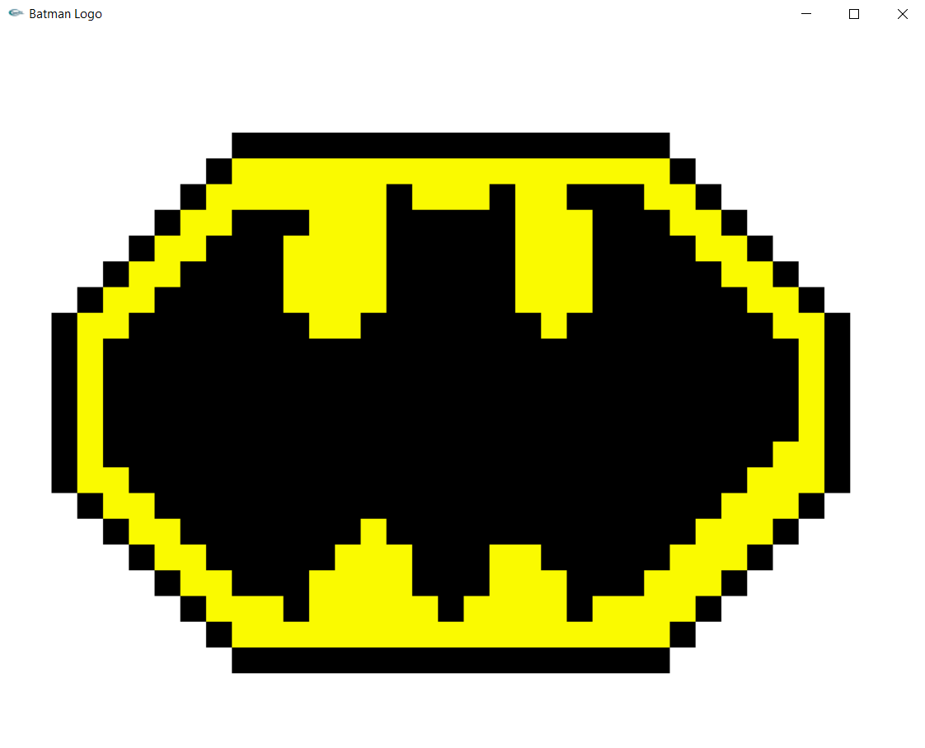

**Code of Superman Logo**

#include<stdio.h>

#include<GL/gl.h>

#include<GL/glut.h>

void display(void)

{

glClear(GL_COLOR_BUFFER_BIT);

glPointSize(4);

//To design red part of logo

glBegin(GL_POLYGON);

glColor3f(1, 0, 0);

glVertex2i(450, 200);

glVertex2i(112.5, 500);

glVertex2i(250, 600);

glVertex2i(650, 600);

glVertex2i(787.5, 500);

glEnd();

//To design yellow part of logo

glBegin(GL_POLYGON);

glColor3f(1, 1, 0);

glVertex2i(450, 250);

glVertex2i(350, 325);

glVertex2i(450, 300);

glVertex2i(550, 325);

glEnd();

//To design yellow part of logo

glBegin(GL_POLYGON);

glColor3f(1, 1, 0);

glVertex2i(325, 355);

glVertex2i(275, 400);

glVertex2i(625, 375);

glVertex2i(575, 350);

glVertex2i(475, 337.5);

glVertex2i(420, 375);

glEnd();

glFlush ();

}

void init (void)

{

glClearColor(0.0,0.0,0.5,0.0); //Dark Blue

glColor3f(0,0,0);

glPointSize(4);

glMatrixMode(GL_PROJECTION);

glLoadIdentity();

gluOrtho2D(0.0,900.0,0.0,700.0);

}

int main(int argc, char** argv)

{

glutInit(&argc, argv);

glutInitDisplayMode(GLUT_SINGLE | GLUT_RGB);

glutInitWindowSize(900, 700);

glutInitWindowPosition(250, 0);

glutCreateWindow("Superman Logo");

glutDisplayFunc(display);

init();

glutMainLoop();

return 0;

}

**Output Figure of Superman Logo**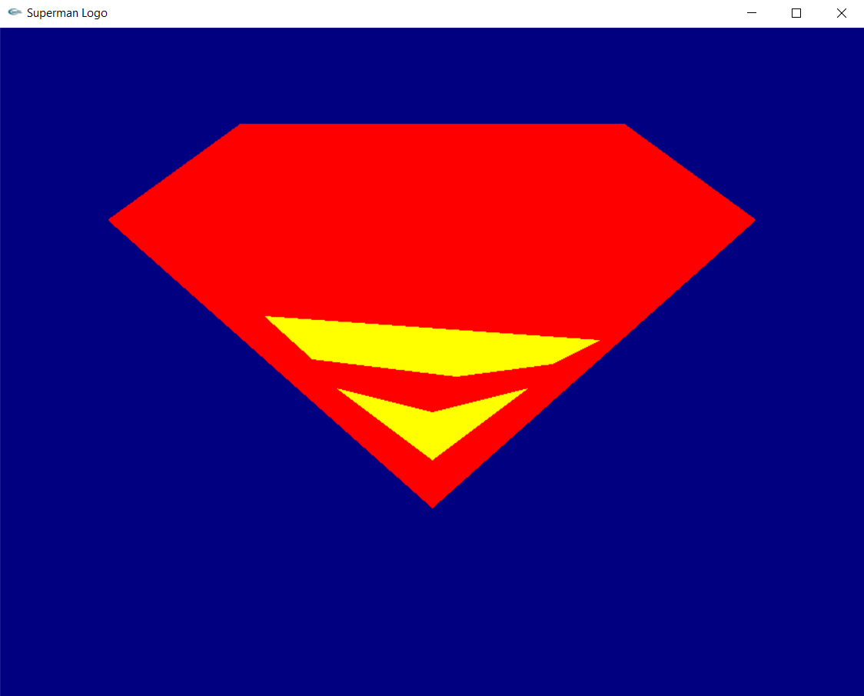

**END**